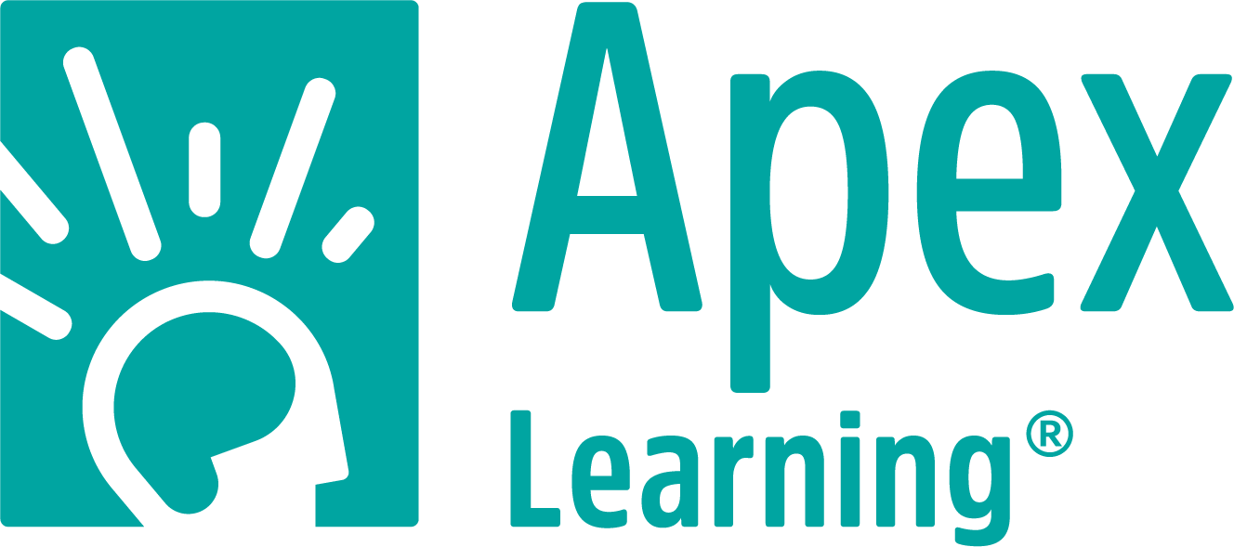 (Insert School Logo Here)

[Insert District Name] Selects Apex Learning to Support Online Learning for Students in Grades [6-12]
The partnership will support the district’s [comprehensive instruction] and [intervention solutions] with [Apex Learning Courses] and [Tutorials]

SEATTLE, WA and [District City, District State] —Month XX, 2020 —[Insert district name] today announced that it has partnered with Apex Learning, a recognized leader in online learning, to support the district’s comprehensive online instruction. The contract will provide grades [6 – 12] with [Apex Learning Courses] and [Tutorials].

“Our mission is to [include your district’s core mission – whatever that it is and how it relates to ensuring every student receives an opportunity succeed,”] said District Leader, District Title, District Name. “[We were looking for a partner that would deliver expansive, flexible digital curriculum coupled with a support team that works closely with us to ensure that our students and educators have access to the tools and resources they need to be successful.]”
[Apex Learning curriculum will seamlessly integrate with the district’s technical vision, simplifying the implementation process from day one, but also supporting their success throughout the process. [Apex Learning Tutorials will be used for grades [6-12] to strengthen skills, address learning gaps and provide personalized, scaffolded pathways for students to mitigate COVID-19 and summer slide, boost readiness to succeed on grade-level and provide students with opportunities for personalized acceleration. Apex Learning Courses will be used in middle school and high school for initial credit and other credit-bearing programs.]
“Ensuring students’ progress in their learning is always top of mind for educators,” said Chris Porter, CEO, Apex Learning. “Now, more than ever, that need is magnified and teachers need resources from partners they can trust to help them identify and address learning loss and ensure every student is on track. Our partnership with [Insert District Name] will provide consistent, quality instruction for the district’s [6-12 grade students] as well as ongoing support and professional development for educators.”
To learn more about Apex Learning Courses and Tutorials, visit: https://www.apexlearning.com/digital-curriculum.

About Apex Learning
An industry leader in online education with deep expertise in digital curriculum, Apex Learning works closely with school districts across the country to implement proven solutions that increase on-time graduation rates and create opportunities for student success in school and beyond. The company is driven by the understanding that supporting the needs of all students – from struggling to accelerated – strengthens schools and creates stronger communities, brighter futures and a more equitable world. Apex Learning is accredited by AdvancED and its courses are approved for National Collegiate Athletic Association eligibility. Apex Learning, where opportunity thrives. For more information, visit http://www.apexlearning.com

About Your District
[This is where you add your boiler plate this is typically included in press releases.]

